- Create one VPC, with 1 public subnet and 1 private subnet.

Objective
Create a VPC with one public subnet and one private subnet. Configure an Internet Gateway and route tables so that the public subnet has internet access while the private subnet has no direct internet access.

Implementation Steps
- Created a VPC named vpc-peer-transit with CIDR block 10.10.0.0/16.
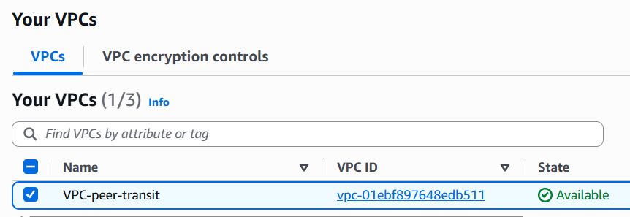

- Created a public subnet:
  - Name: public-subnet
  - CIDR: 10.10.0.0/20
- Created a private subnet:
  - Name: private-subnet
  - CIDR: 10.10.16.0/20

- Created an Internet Gateway named vpc-peer-transit-igw.
- Attached the Internet Gateway to vpc-peer-transit. 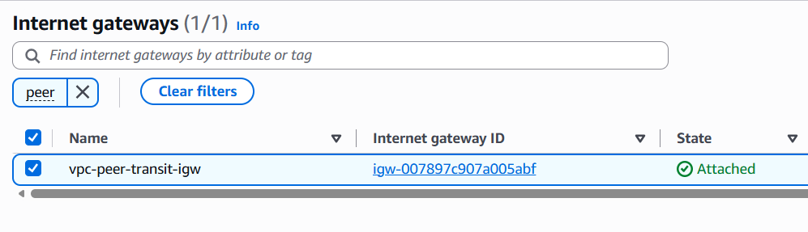

- Created a route table named public-rt.
- Added the following route to public-rt:
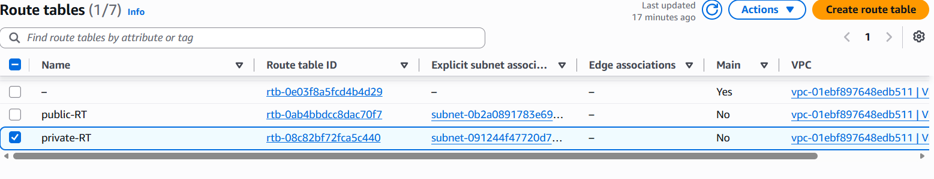
- Destination: 0.0.0.0/0
Target: Internet Gateway
- Associated public-subnet with public-rt.
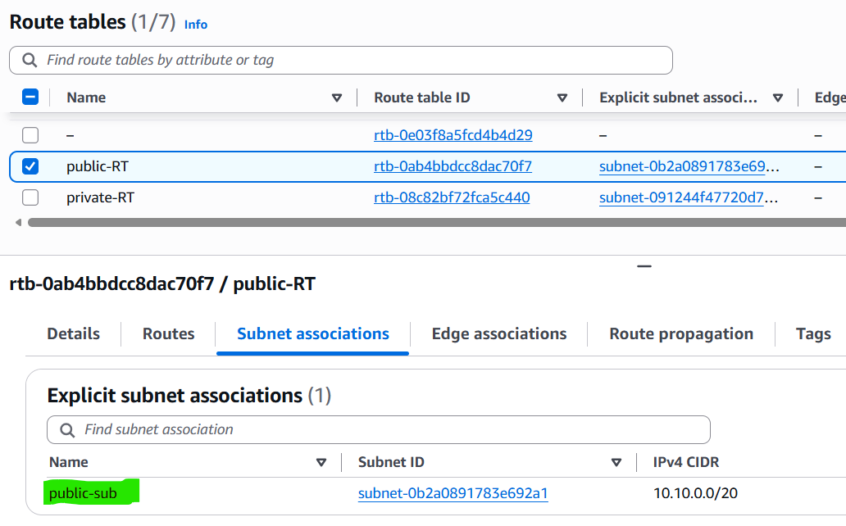
- Created a separate route table named private-rt.
- Associated private-subnet with private-rt.
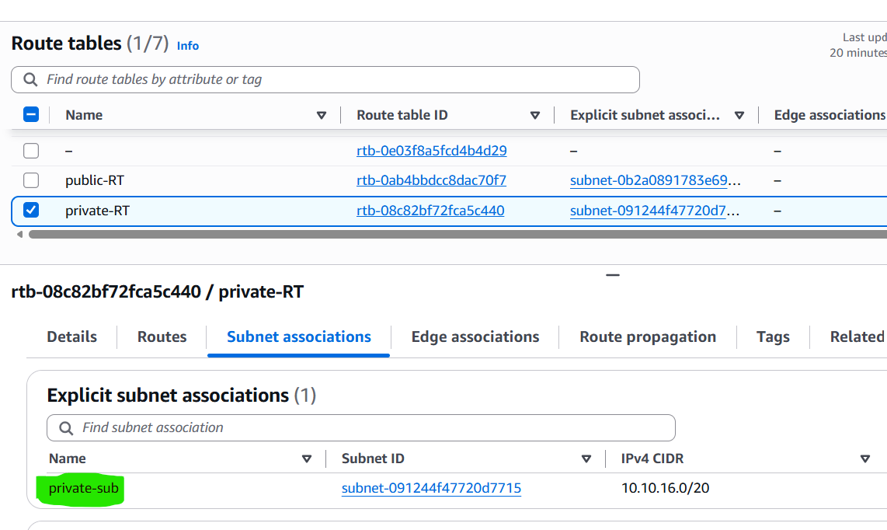
- Did not add an Internet Gateway route to private-rt.

Result
Successfully created vpc-peer-transit with one public subnet and one private subnet.
- The public subnet has a route to the Internet through the Internet Gateway.
- The private subnet has no direct route to the Internet Gateway.
- Separate route tables were used to control traffic for public and private subnets.

Architecture:
VPC: vpc-peer-transit
CIDR: 10.10.0.0/16
│
├── public-subnet
│ CIDR: 10.10.0.0/20
│ │
│ └── public-rt
│ ├── 10.10.0.0/16 → local
│ └── 0.0.0.0/0 → Internet Gateway
│
└── private-subnet
CIDR: 10.10.16.0/20
│
└── private-rt
└── 10.10.0.0/16 → local

- Enable VPC peering for cross-region.

Objective
Create a VPC peering connection between two VPCs located in different AWS Regions and enable private communication between resources in both VPCs.

Architecture
Mumbai Region (ap-south-1) Singapore Region (ap-southeast-1)

vpc-peer-transit cross-peering-vpc
CIDR: 10.10.0.0/16 CIDR: 10.20.0.0/16
│ │
│ VPC Peering Connection │
└─────────────── PCX ────────────────────────┘
│ │
Mumbai EC2 Singapore EC2
10.10.14.215 10.20.7.91

Resources Used
Resource | Mumbai | Singapore
Region | ap-south-1 | ap-southeast-1
VPC | vpc-peer-transit | cross-peering-vpc
VPC CIDR | 10.10.0.0/16 | 10.20.0.0/16
Subnet | public-subnet | cross-peering-subnet
Peering Connection | mumbai-singapore-peering | Same connection

Implementation Steps

1. Created the second VPC
Created cross-peering-vpc in the Singapore Region with:
CIDR: 10.20.0.0/16
The CIDR does not overlap with the Mumbai VPC:
Mumbai: 10.10.0.0/16
Singapore: 10.20.0.0/16

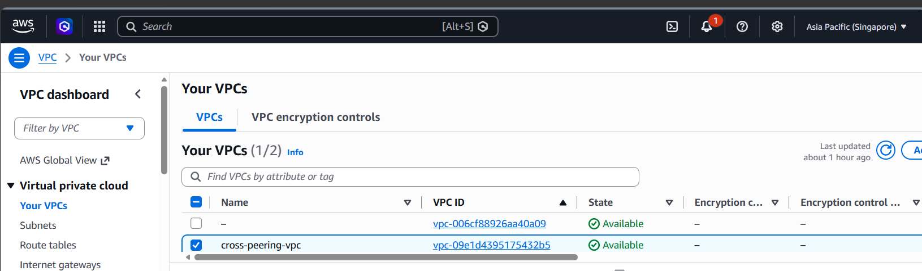

2. Created a subnet in Singapore
Created:
Subnet: cross-peering-subnet
CIDR: 10.20.0.0/20

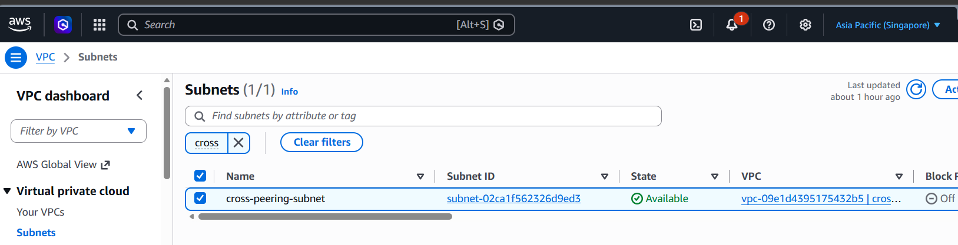

3. Created the VPC peering connection
From the Mumbai Region:
- Local VPC: vpc-peer-transit
- Peer Region: Singapore (ap-southeast-1)
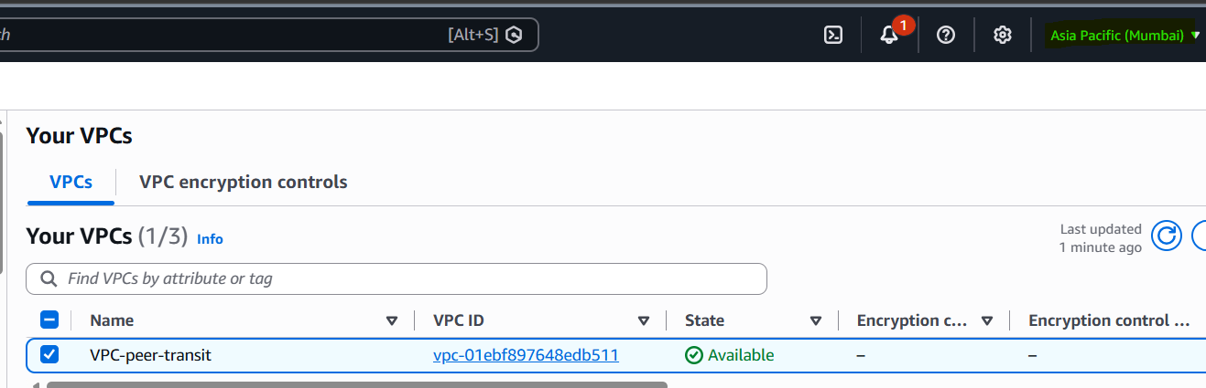

- Peer VPC: cross-peering-vpc
- Peering connection name: mumbai-singapore-peering
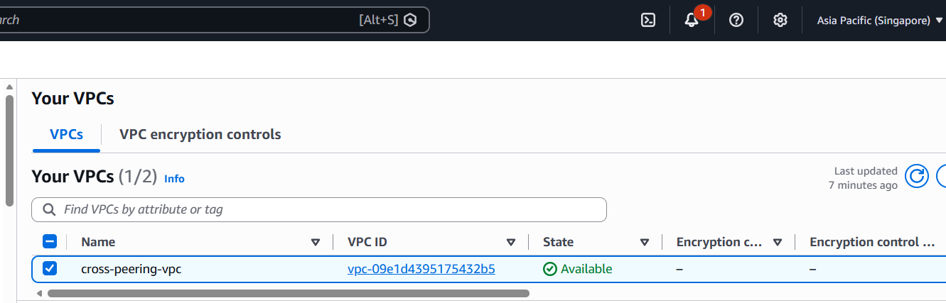

The request initially had the status:
Pending Acceptance

4. Accepted the peering request
Switched to the Singapore Region and accepted the peering request.
Final status:
Active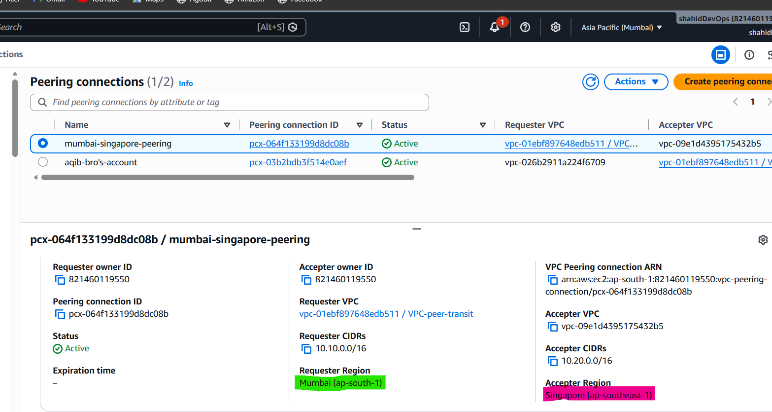

5. Configured the Mumbai route table
Added the route to the route table associated with the Mumbai EC2 subnet:
Destination: 10.20.0.0/16
Target: VPC Peering Connection
This allows traffic from Mumbai to reach the Singapore VPC.

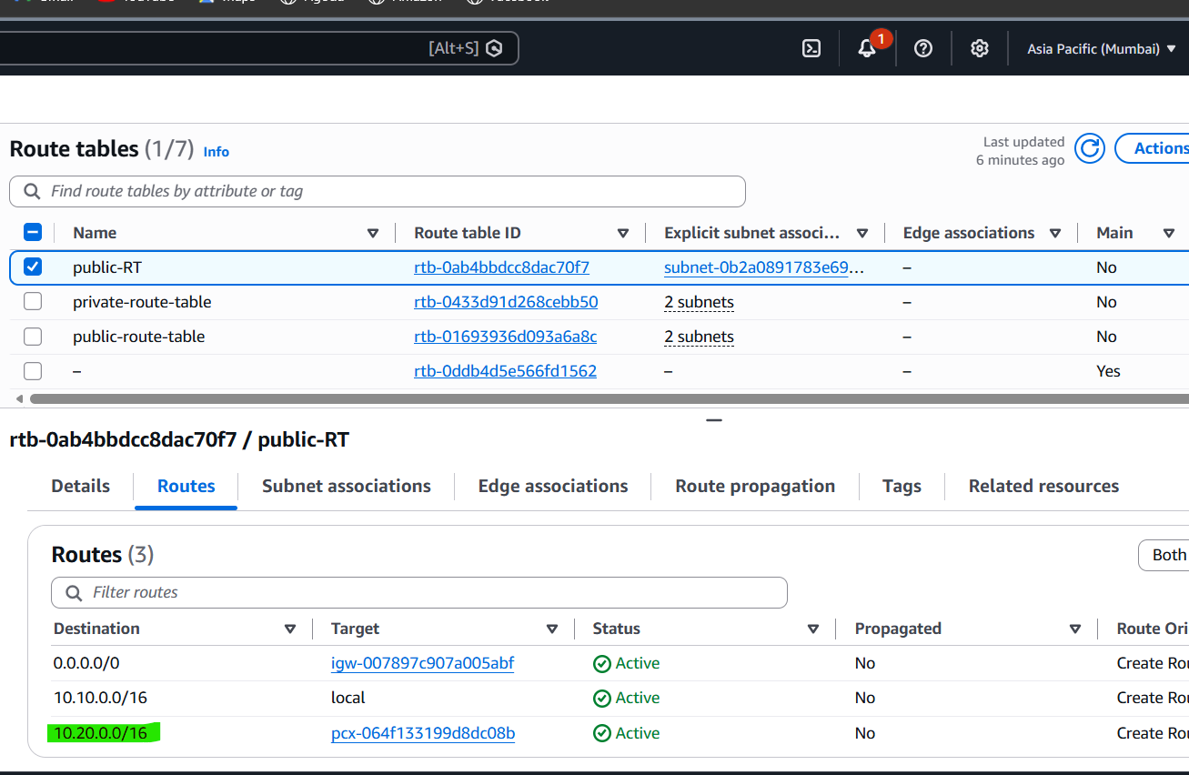

6. Configured the Singapore route table
Added:
Destination: 10.10.0.0/16
Target: VPC Peering Connection
This provides the return path from Singapore to Mumbai.

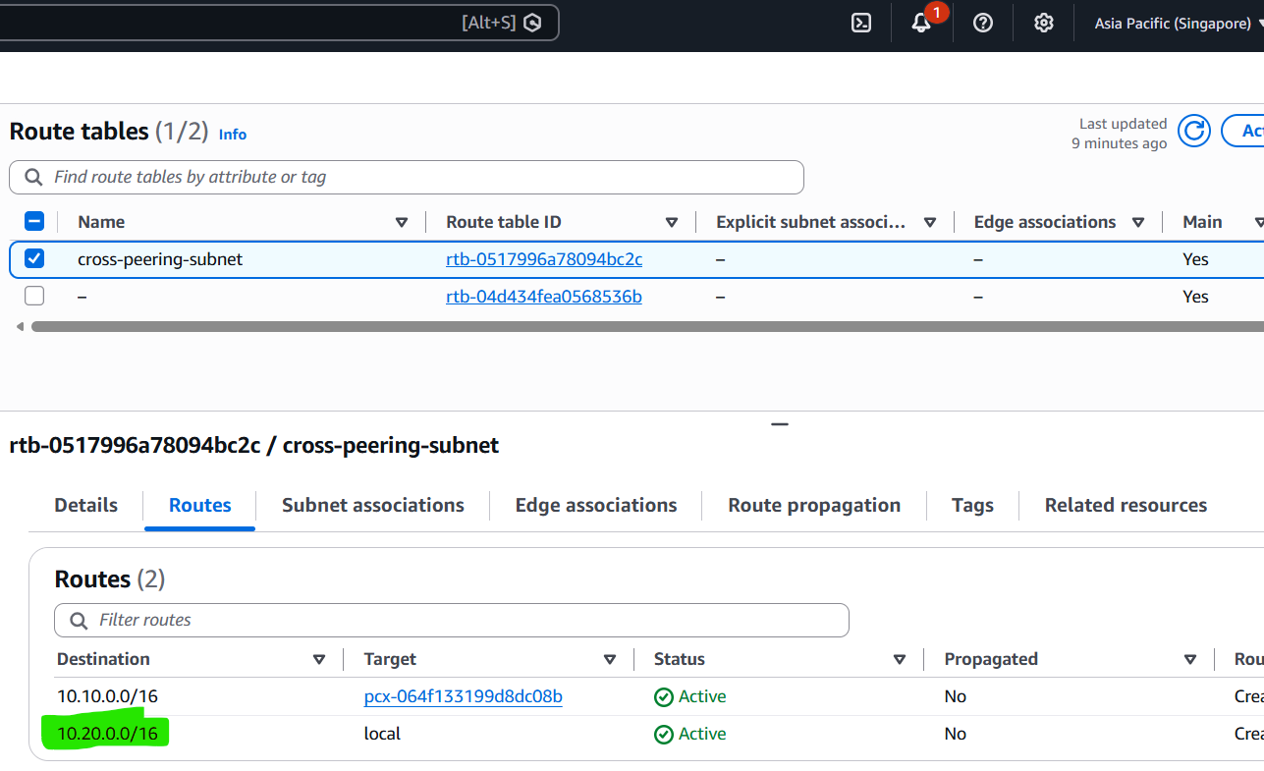

7. Launched EC2 instances for connectivity testing
One EC2 instance was launched in each VPC:
Mumbai EC2 private IP: 10.10.14.215

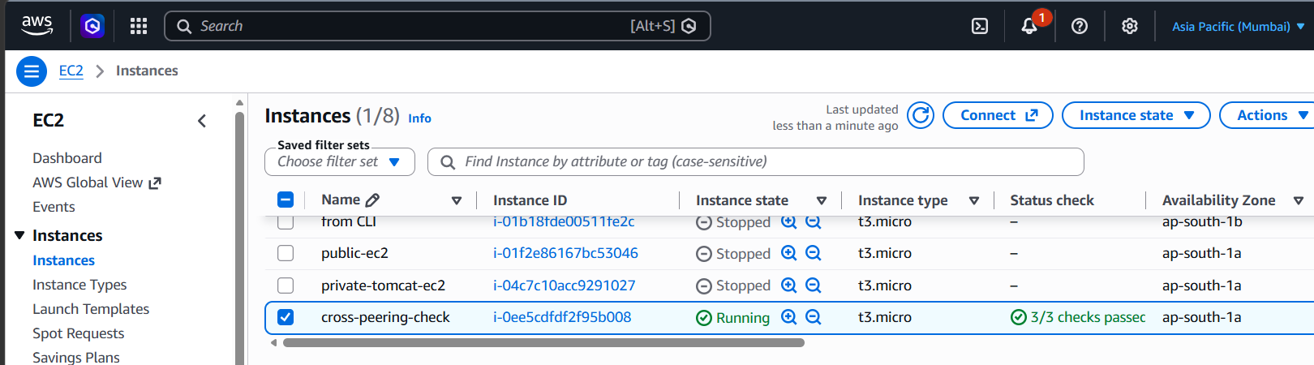

Singapore EC2 private IP: 10.20.7.91

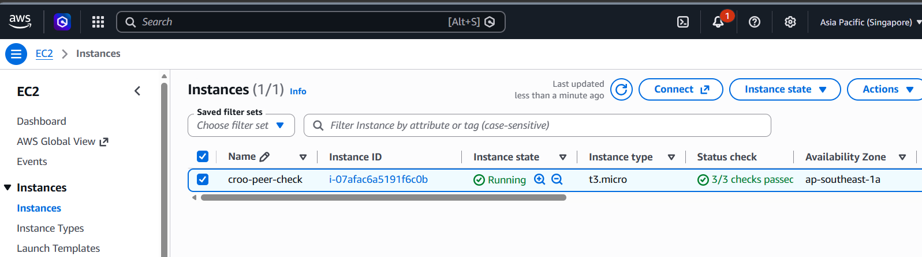

8. Configured the security group
The Singapore EC2 initially used a security group rule that referenced the security group itself. This did not allow ICMP traffic from the Mumbai VPC.
Added a new inbound rule:
Type: All ICMP - IPv4
Source: 10.10.0.0/16
This allowed ping traffic from the Mumbai VPC.

Connectivity Test
From the Mumbai EC2:
ping 10.20.7.91
The Singapore EC2 was accessed using its private IP address, not its public IP.
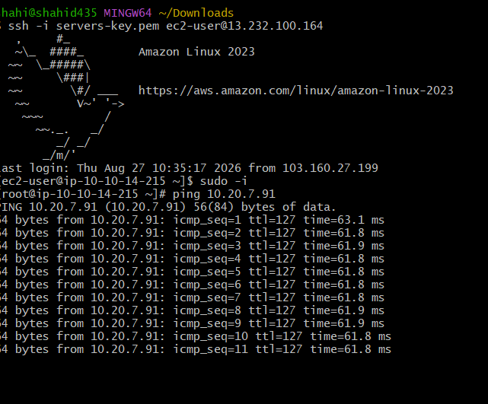

Result
Successfully configured a cross-region VPC peering connection between Mumbai and Singapore.
- Peering connection status: Active
- Non-overlapping VPC CIDR ranges were used.
- Routes were configured in both directions.
- Security group rules allowed the required traffic.
- Communication was tested using private IP addresses across the VPC peering connection.

- Enable VPC peering for cross-account (you can collaborate with your friend to do this task).

Objective
Establish a VPC peering connection between VPCs located in two different AWS accounts and enable private communication between resources in those VPCs.

Architecture
AWS Account A AWS Account B
───────────────── ─────────────────

VPC-A VPC-B
10.10.0.0/16 10.30.0.0/16
│ │
└──── Cross-Account VPC Peering ────────┘
│
Active

Prerequisites
- Two separate AWS accounts.
- One VPC in each account.
- Non-overlapping VPC CIDR ranges.
- VPC ID of the peer VPC.
- AWS Account ID of the peer account.

Implementation Steps
- Create or select one VPC in each AWS account.
- Ensure the VPC CIDR ranges do not overlap.
Example:
Account A VPC: 10.10.0.0/16
Account B VPC: 10.30.0.0/16
- Create a VPC peering connection from either AWS account.
- While creating the connection, select:
  - Peer VPC owner: Another account
  - Enter the peer AWS Account ID.
  - Enter the peer VPC ID.
  - Select the correct peer Region.
- The peering connection enters the Pending Acceptance state.
- Log in to the peer AWS account and accept the peering request.
- Verify that the peering connection status becomes:
Active
- Add a route in Account A's route table:
- Destination: Peer VPC CIDR
Target: VPC Peering Connection
- Add a return route in Account B's route table:
- Destination: Account A VPC CIDR
Target: VPC Peering Connection
- Configure security groups to allow the required traffic between the two VPCs.
- Test connectivity between EC2 instances using their private IP addresses.
Example:
ping <peer-ec2-private-ip>

Important Points
- The peering connection can be initiated from either AWS account.
- The other AWS account must accept the request.
- VPC CIDR ranges must not overlap.
- An Active peering connection alone does not provide connectivity.
- Route tables must be configured on both sides for two-way communication.
- Security groups and Network ACLs must allow the required traffic.
- Routing is configured using the peer VPC CIDR, not an individual EC2 IP address.
- Connectivity between instances is tested using their private IP addresses.

Result
Successfully established a cross-account VPC peering connection between two AWS accounts. The peering connection became Active, routing was configured to direct traffic through the peering connection, and connectivity between resources was verified using private IP communication.

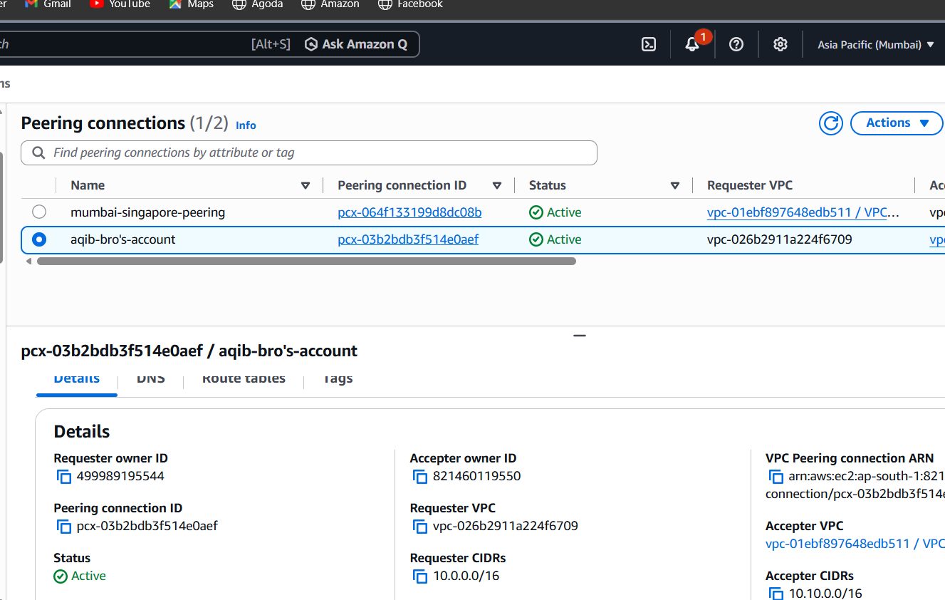
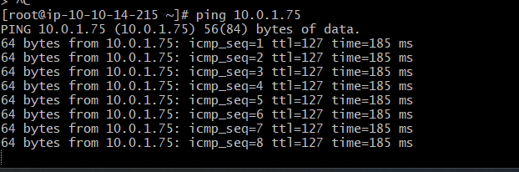

4.Set up a VPC Transit Gateway.

Objective
Create a VPC Transit Gateway (TGW) and use it to provide private connectivity between multiple VPCs through a centralized network hub.

Architecture
Transit Gateway
devops-tgw
│
┌─────────────┴─────────────┐
│ │
│ │
VPC Attachment VPC Attachment
│ │
tgw-vpc-1 tgw-vpc-2
10.40.0.0/16 10.50.0.0/16
│ │
EC2-1 EC2-2
10.40.1.x 10.50.1.x

Resources Used
Resource | Configuration
Region | Mumbai (ap-south-1)
Transit Gateway | devops-tgw
TGW ID | tgw-061af904b96d12866
VPC 1 | tgw-vpc-1
VPC 1 CIDR | 10.40.0.0/16
VPC 1 Subnet | tgw-subnet-1
Subnet 1 CIDR | 10.40.1.0/24
VPC 2 | tgw-vpc-2
VPC 2 CIDR | 10.50.0.0/16
VPC 2 Subnet | tgw-subnet-2
Subnet 2 CIDR | 10.50.1.0/24

Implementation Steps

1. Created two VPCs
Created two VPCs with non-overlapping CIDR ranges:
tgw-vpc-1 → 10.40.0.0/16
tgw-vpc-2 → 10.50.0.0/16
Both VPCs were created in the Mumbai Region.

2. Created subnets
Created one subnet in each VPC:
tgw-subnet-1 → 10.40.1.0/24
tgw-subnet-2 → 10.50.1.0/24
These subnets were used for the VPC attachments and EC2 instances.

3. Created the Transit Gateway
Created a Transit Gateway:
Name: devops-tgw
The Transit Gateway acts as a central networking hub between attached VPCs.

4. Created VPC attachments
Created a Transit Gateway attachment for each VPC:
tgw-vpc-1
│
└── tgw-vpc-1-attachment
│
▼
devops-tgw

tgw-vpc-2
│
└── tgw-vpc-2-attachment
│
▼
devops-tgw
Both attachments reached the Available state.

5. Configured VPC route tables

Route table for tgw-vpc-1
Added:
Destination: 10.50.0.0/16
Target: devops-tgw
This directs traffic intended for tgw-vpc-2 to the Transit Gateway.

Route table for tgw-vpc-2
Added:
Destination: 10.40.0.0/16
Target: devops-tgw
This provides the return route to tgw-vpc-1.

6. Verified Transit Gateway route table
The TGW route table contained routes for both VPC CIDR ranges:
10.40.0.0/16 → tgw-vpc-1 attachment
10.50.0.0/16 → tgw-vpc-2 attachment
These routes allow the Transit Gateway to forward traffic to the correct VPC attachment.

7. Configured internet access for EC2 testing
To access the EC2 instance in tgw-vpc-1 from a local machine:
- Created and attached an Internet Gateway to tgw-vpc-1.
- Added the following route:
0.0.0.0/0 → Internet Gateway
- Launched an EC2 instance with Auto-assign Public IPv4 enabled.
- Allowed SSH access from the required source in the security group.
The route table contained:
10.40.0.0/16 → local
10.50.0.0/16 → devops-tgw
0.0.0.0/0 → Internet Gateway

8. Tested connectivity
Logged into the EC2 instance in tgw-vpc-1 using its public IP:
ssh -i key.pem ec2-user@<public-ip>
Then tested connectivity to the EC2 instance in tgw-vpc-2 using its private IP:
ping <vpc2-private-ip>
Traffic flow:
EC2 in tgw-vpc-1
│
▼
VPC Route Table
│
▼
Transit Gateway
│
▼
VPC Attachment
│
▼
EC2 in tgw-vpc-2

Important Points
- A Transit Gateway is a centralized network hub that connects multiple VPCs and networks.
- Each VPC must be connected through a Transit Gateway attachment.
- VPC route tables must direct peer VPC traffic to the TGW.
- The Transit Gateway route table must know which attachment leads to each destination.
- Transit Gateway attachments alone do not automatically guarantee end-to-end connectivity.
- Security groups and Network ACLs must allow the required traffic.
- A Transit Gateway provides private network connectivity, not internet access.
- Internet access requires an Internet Gateway, public route, public IP, and appropriate security group rules.
- Transit Gateway is more scalable than creating many individual VPC peering connections.

Result
Successfully configured a VPC Transit Gateway connecting tgw-vpc-1 and tgw-vpc-2. Both VPCs were attached to the same Transit Gateway, routing was configured in both directions, and the architecture was prepared for private communication between EC2 instances through the Transit Gateway.

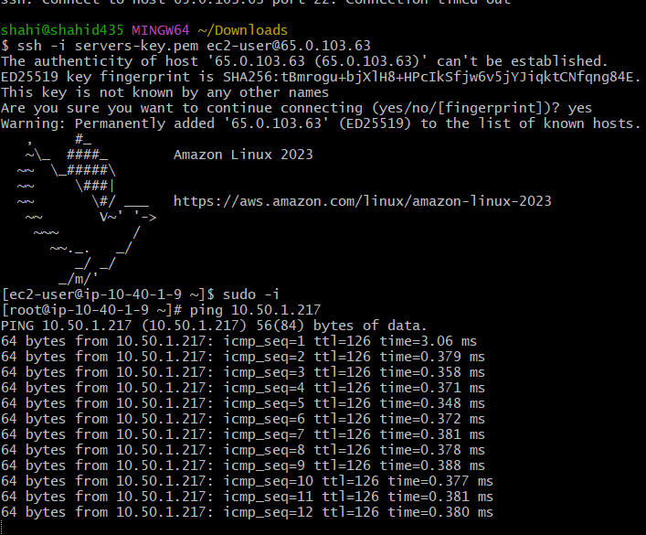

5.Set up a VPC Endpoint.

Objective
Create an Amazon S3 Gateway VPC Endpoint to allow resources inside a VPC to access Amazon S3 through the AWS network without requiring the traffic to go through an Internet Gateway or NAT Gateway.

Resources Used
Resource | Configuration
Region | Mumbai (ap-south-1)
VPC | my-devops-vpc
VPC CIDR | 192.168.0.0/24
Endpoint Name | my-devops-s3-endpoint
Service | com.amazonaws.ap-south-1.s3
Endpoint Type | Gateway
Route Tables | private-route-table, public-route-table

Implementation Steps

1. Opened VPC Endpoints
Navigated to:
AWS Console → VPC → Endpoints → Create endpoint

2. Configured the Endpoint
Selected:
Name: my-devops-s3-endpoint
Service category: AWS services
Service region: ap-south-1
Service: com.amazonaws.ap-south-1.s3
Endpoint type: Gateway
The Cross Region endpoint option was left unchecked because the VPC and S3 service endpoint were being used within the same AWS Region.

3. Selected the VPC
Selected:
VPC: my-devops-vpc
CIDR: 192.168.0.0/24

4. Associated Route Tables
Selected the route tables used by the VPC:
private-route-table
public-route-table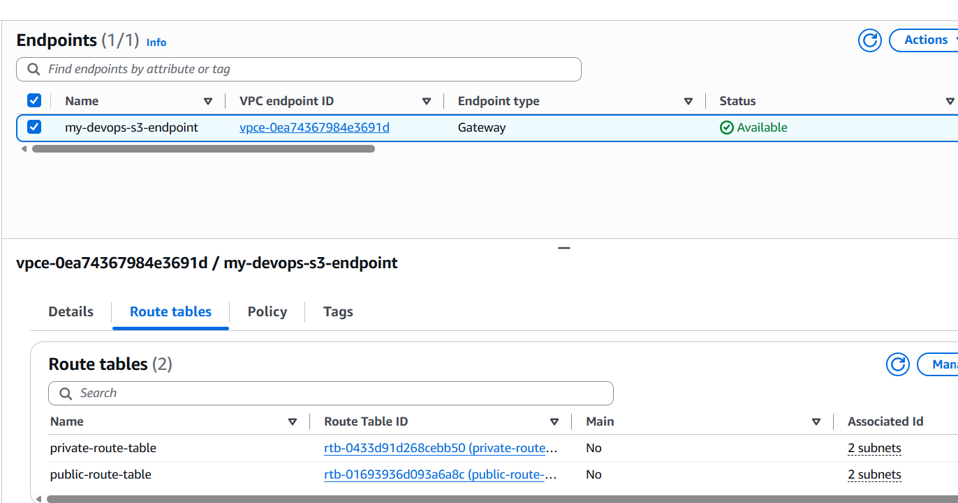
AWS automatically added the S3 prefix-list route to the selected route tables.
The route appears similar to:
Destination: pl-xxxxxxxx
Target: vpce-xxxxxxxx
The pl-xxxxxxxx value represents the AWS-managed prefix list for Amazon S3.

5. Configured Endpoint Policy
The default endpoint policy was used:
Full Access
Access is still controlled by IAM permissions and other applicable AWS policies.

6. Created the Endpoint
Created the endpoint and verified its state:
State: Available

Architecture
Resource inside my-devops-vpc
│
▼
Route Table
│
▼
S3 Gateway Endpoint
│
▼
Amazon S3

Result
Successfully created an Amazon S3 Gateway VPC Endpoint in my-devops-vpc.
The endpoint is associated with both the private-route-table and public-route-table, allowing resources using those route tables to access Amazon S3 through the VPC Endpoint.

